LYNFIELD COLLEGE
2026 STUDENT ASSESSMENT COVER SHEET

Course Title |  |  |  | 2PAD
91897: Use advanced processes to develop a digital technologies outcome
Achievement Standard | 91897 | Level | 2 |  | Version | 1 | Credits | 6

Due Date: Term 3, Day 9, Week 2 (27 July 2026)
Achievement Criteria:

Achieved | Merit | Excellence
Use advanced processes to develop a digital technologies outcome. | Use advanced processes to develop an informed digital technologies outcome. | Use advanced processes to develop a refined digital technologies outcome.

Authenticity statement:

The work that I have submitted for this assessment is my own.
I understand any material used and/or quoted that is not my own must be acknowledged in the appropriate manner. I understand that the use of chatbots, generative AI, paraphrasing tools, or other tools that can automatically generate content is not permitted. Material generated by these tools has not been included in this submission.
I understand any material used and/or quoted that is not my own must be acknowledged in the appropriate manner.
I have acknowledged all direct quotes and references used in this assessment.
I understand that plagiarism and/or collusion with other students may result in disciplinary action and a Not Achieved grade being given.
If submitting a digital copy of this assessment I agree to the above.
I give permission for my assessment to be given to the external assessor for marking.

STUDENT’S NAME :…………………… DATE: ………..

STUDENT’S SIGNATURE .........................................................

Grade awarded:

Not Achieved | Achieved
Merit | Excellence

TEACHER’S SIGNATURE .........................................................

Instructions
- Read all instructions carefully.
- Complete ALL tasks.
- Ensure your name is on every page of your assessment.

Conditions
- The timeframe for completion will be set by your Assessor according to a particular classroom situation.
- You must follow legal ethical and moral responsibilities when creating your documents.

Note to Assessors:

You will need to provide candidates with a copy of the documented policies and procedures or commonly accepted practices of your organisation, prior to being assessed against this achievement standard.
Context/Te Horopaki
This is an integrated assessment activity supporting a project-based approach that assesses against two achievement standards. Students will use advanced processes to plan, test and trial a party hire store program. They are required to implement advanced programming techniques within their hire program.
Using advanced processes will support the students to develop a refined party hire program that has been comprehensively tested and debugged. Both achievement standards require testing to improve the quality and functionality of the outcome.
Students will use python programming language and tkinter, as it supports a range of advanced programming techniques.
Conditions/Ngā Tikanga
You will be given two identified checkpoints with as you work through this assessment activity to ensure they have an opportunity to ask questions and gather feedback.
Resource requirements/Ngā Rauemi
Students will need access to software that will allow them to document their development process. This could be in the form of a document, testing document or google slides.
They will also need access to project management and version control tools (which may include a mixture of digital and non-digital resources).

The format of the final outcome is a computer program.
Students will need to supply evidence of using recognised and appropriate project management tools and techniques to plan and manage the development of the computer program. This will include trialling and testing the components of the program (see student task for more details).

Achieved
Use advanced processes to develop a digital technologies outcome involves:
- using appropriate project management tools and techniques to plan the development of a digital technologies outcome.
- decomposing the outcome into smaller components
- trialling the components of the digital technologies outcome
- testing that the digital technologies outcome functions as intended
- explaining relevant implications.
Merit
Use advanced processes to develop an informed digital technology outcome
involves:
- effectively using project management and version control tools and techniques to
- manage the development of a digital technologies outcome.
- trialling multiple components and/or techniques and selecting those which are
- most suitable
- using information appropriately from testing and trialling to improve the
- functionality of the digital technologies outcome
- addressing relevant implications.
Excellence
Use advanced processes to develop a refined digital technologies outcome involves:
- discussing how the information from planning, testing and trialling of components assisted in the development of a high-quality outcome.

Below are some examples of project management and version control tools and techniques and relevant implications.

Examples of project management and version control tools and techniques include:
● saving backup copies with a logical file naming system
● using collaboration tools
● using simple version control software applications
● using tools or systems to plan tasks and milestones
● adjusting key actions and tasks where appropriate

Examples of relevant implications include:
● social
● cultural
● legal
● ethical
● intellectual property
● privacy
● accessibility
● usability
● functionality
● aesthetics
● sustainability and future proofing
● end-user considerations
● health and safety.

Planning Tools may include:

The template gallery in Google Sheets has Project Management tools for drafting up a plan. They are Gantt Chart, Project Timeline, and Project Tracking. Complete your own research to find a tool that suits you.

Gantt Chart – this is a bar chart that tells a visual story. It is like a visual to-do list. Filling in cells with different colours, using clear labels and headings and breaking down tasks into small chunks helps to determine a robust workflow.

Project Timeline – this is similar in looks to a Gantt Chart. It has clear stages.

Project Tracking – this tool is less visual. It works with task descriptions, start and end dates.

Trello Board: progress tracking with your milestones.

Task size table: estimate of how long your task is.

Also refer to the training education website for more examples.
Other Resources

Project Management Tools and Techniques:

A project has a beginning and an end with lots of steps (tasks, processes) that are completed at various points along the project timeline. In this context, project management tools and techniques are used to document the process of outcome development. Project Management involves planning the steps to take and documenting them as they are taken. Progress is tracked and end users are consulted.

It is important that you do your own research to find a project management tool that suits your workflow. From the standard, examples of project management tools and techniques include:

• Agile or waterfall techniques

• Kanban

• Version control software

• Collaboration tools

NOTE 1: It is not a requirement that you utilise all of these techniques and tools. It is up to you what you use. However, you must use at least one tool to manage your project and Justify it.

NOTE 2: Check the usability of your Project Management Tool. Some tools offer you 30 days free, others restrict the number of cards/boards you can use.

These are software development methodologies.
Agile – continuous iteration. Changes allowed in the project.

Waterfall – sequential order. The project only moves forward if the previous step or phase is complete. Simplest technique for small projects.
https://www.youtube.com/watch?v=egF9-FejbsA

Tools:

Kanban – Kanban is a visual process and project management tool.

Version Control – saving each iteration as the outcome is developed allows the designer to revisit an earlier version at any time.
Collaboration Tools - examples include Trello, Padlet, Figma, Microsoft
Teams, Microsoft Tasks, Microsoft ToDo, Fleep, Monday.com. These can be used to showcase your development for feedback from end users. Google Forms can be used to gather feedback, or a questionnaire created in other software such as Microsoft Word. Choosing the right collaborative tool is important for sharing your development with end users and collecting feedback. Slack, for example, can be integrated with Google Forms.
Google Forms are one way of questioning end users. Responses are automatically collated in a Google Sheet.

Trial and Test

- For each component, trial and test with end users
- Repeat the cycles of trialling (gather information) and testing (make decisions) until you are satisfied that you have iterated enough to have a high-quality outcome.

Reflection

Create a document and save it as ‘Reflection’. Set up headings and discuss the questions as outlined below.
- How has the combination of planning, utilising project management tools, collaboration tools, and feedback tools helped you to create a high-quality outcome?
- How has the information you have gathered from the planning, trialling and testing of components lead to the creation of your final outcome?
- How have you addressed your relevant implications in your final outcome?

The below questions allow you to follow a structured way of approaching the AS91897. Note that where it says (Add answer here) an answer is required. In order to receive an achieved in this project all questions must be answered at a reasonable level (more than just one sentence).

Concept design (Sketch/Draft):

Use the below space to add three sketch/draft concepts of your program. Remember to sketch all windows, images, buttons and text. You can use photos of your hand sketch, lucid charts or other illustrative software to complete this.

Concept 1

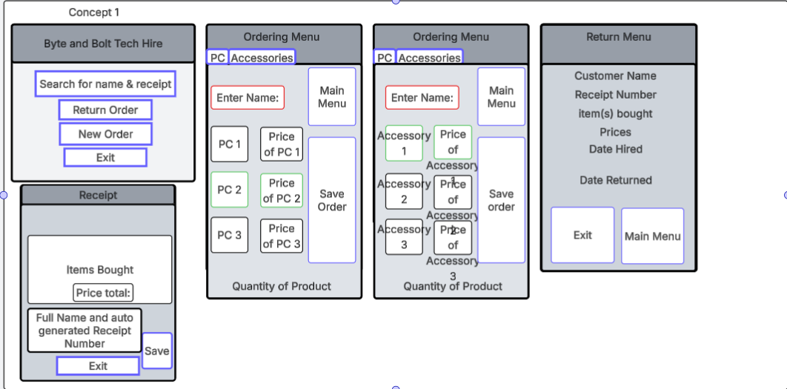

Concept 2

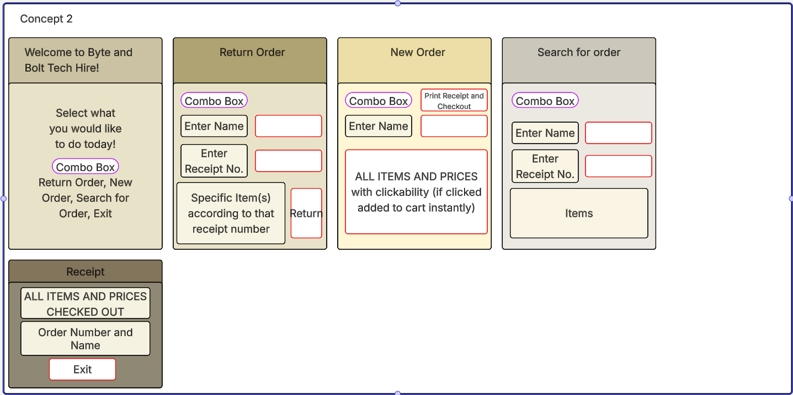

Concept 3

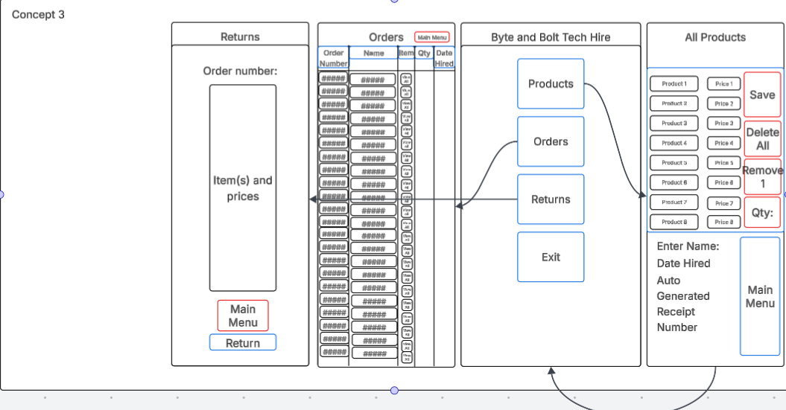

Final Concept

In a few sentences and referring to the relevant implications justify why you have chosen this concept.


I have chosen this concept as it has proven to be the best concept in a survey I had sent out to some of my classmates, where it was ranked number one among the three provided. However, many people (including myself) have voiced a concern for the lack of colour, provided by the sharp monotone millennial grey used to create the text boxes. To address that matter, I will switch to a more colourful scheme, where I use a mix of well thought out beiges and blues in my colours for the GUI.

Flow chart
There are 5 flowcharts, as I have decided to screenshot each block separately, for the purpose of being able to zoom into the document and being able to read it. The 5 flowcharts consist of; my main menu, flowchart 1; my return order menu, flowchart 2; my new order menu, flowchart 3; my show order menu, flowchart 4; and my checkout menu, flowchart 5. It is split into 5 parts for better readability, as stated above.

Key:
Oval – Start
Circle – Connector. There are 5 total connectors, m, r_o, n_o, s_o and c_w. “m” connects to the main menu. “r_o” connects to the return order menu. “n_o” connects to the new order menu. “s_o” connects to the show order menu. “c_w” connects to the checkout window.
Lined Boxes – Functions or predefined processes.
Boxes – process that the machine will encounter and go through.
Diamond – decision box (an if else statement)
Parallelogram – input/output (shows the user whatever is stated).
Flowchart 1 – Main Menu
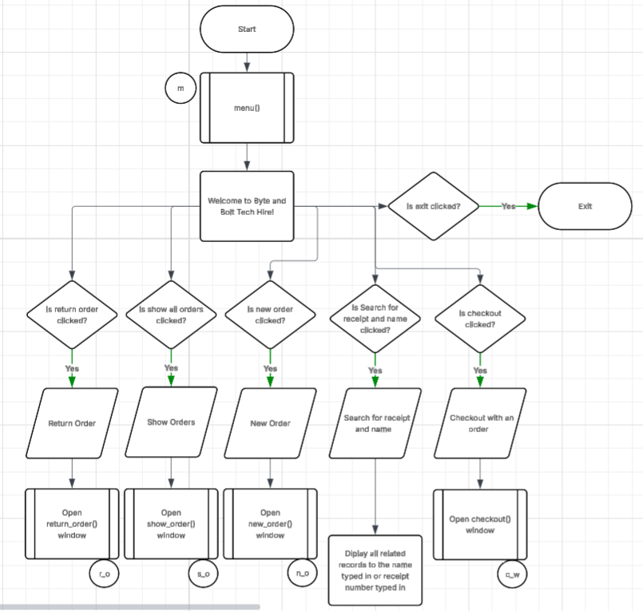
This flowchart helps visualise the main purpose of the menu in a readable context, which is to help establish my thought process while creating the main menu

Flowchart 2 – Return Order Menu
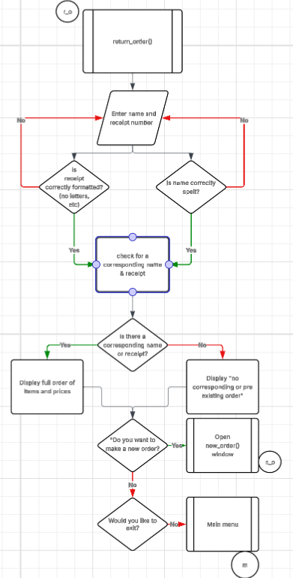
This flowchart helps others who aren’t me understand what my intent, and the purpose of the program is. This menu will allow the user to return any set given amount of items, provided they remember their receipt number or items they may have ordered.

Flowchart 3 – New Order Menu
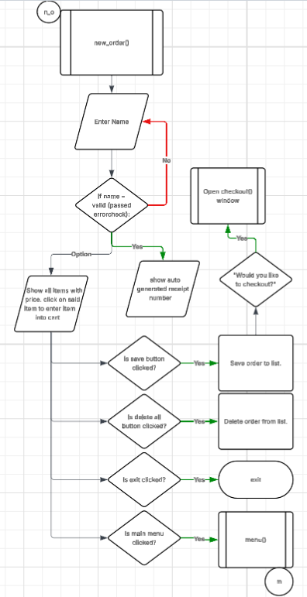
This is my third flowchart, created for the purpose of establishing the new_order() menu, used by the program to allow the user to make a new entry into the save file for a new order.

Flowchart 4 – Show Orders
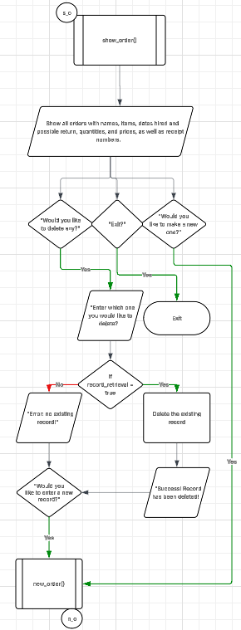
This flowchart was made to help visualise and understand my though process in developing the show order menu, where you are able to view all the orders and their details.

Flowchart 5 – Checkout Window
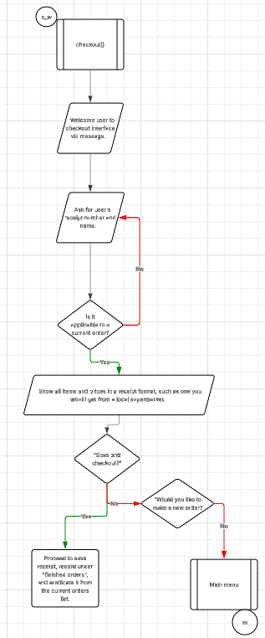
This was my final flowchart that I had created for my project. This helped me visualise the logic for the user to checkout the hired tools. This will save the order in the saved order list, while giving the date returned and date hired.

Project Management Tools:

Two Project Management Tools chosen along with justification note: You need to show a timeline of development:

(Add a link to your Trello development/Gannt Chart/Flow Diagram for your project here)

Link to Flowchart
Link to Trello Board

Trello Board as of 20/05/2026
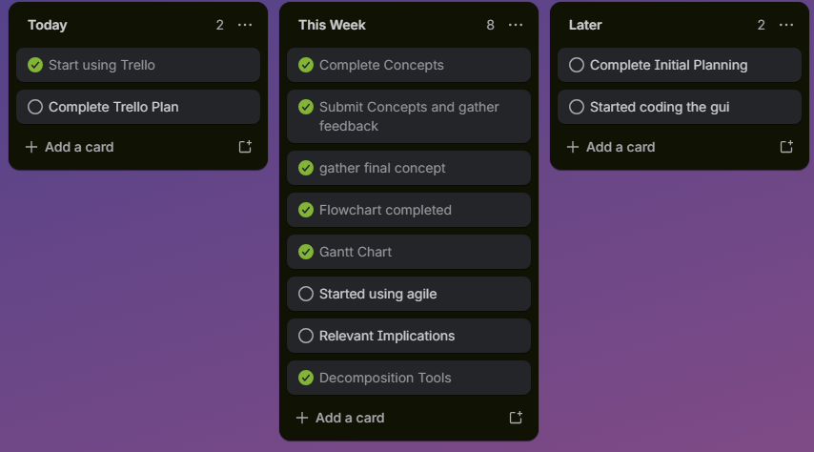
This is my Trello board that I need to plan this project out, so that I can meet deadlines for submitting work and checkpoints, as well as staying on time to complete the project. The Trello board helps me visualise the tasks left and the completed tasks, so that I can judge the amount of further effort needed accurately.

Link to Gantt Chart
Gantt Chart as of 20/05/2026
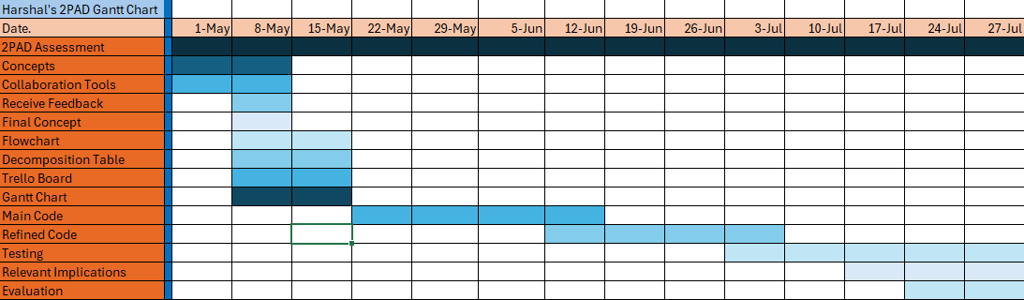
This is my Gantt chart that I also use in tandem with my Trello board to help guide me on the project timeline. The Gantt chart allows me to visualise which parts of the project need to be done and can question whether I am following my own timeline or not.

The Trello board and Gantt chart may both do the same thing, but the Trello board and Gantt chart do have some differences. Trello board allows you to see tasks that need to be completed within a specific time, while the Gantt chart allows you to see tasks that need to be done according to a timeline. E.g. in my Trello board I have only do things listed, while in the Gantt chart I have do things in week x. Both have their strengths and weaknesses, but both used together undercut their own weaknesses.

Decomposition Tools:

One Decomposition Tool chosen along with justification:
GUI | Window | Button Layout  Colour  Size  - Width  - Length  Icons | All buttons will be primarily on the right side of each window except for main menu, where the buttons are in the middle.  The save and main menu will be a lighter tan compared to the background, while the delete and edit buttons will be a more reddish tan. Checkout will be a more bluish tan.  The buttons will all be having the same dimensions as each other, with the width being 15 and the length being 20.  Some buttons will have an icon, such as checkout having a shopping cart, and search for receipts will have a magnifying glass.
 | Fonts | Size  Style  Colour | The size of the font for button text will be around 12px. Receipt font size will be slightly shorter at around 8px. The main title will be 20px.  The style of the fonts will be consistent within the program, with them all being the same. They will be dressed in the font garamond.  The font throughout the entirety of the program will be black.
 | Buttons | Shape  Frame | Most button shapes will be rectangular with circular edges.  2px thick borders.
 | List of Items | Layout | 4x4 window with item as column 1, price as column 2, and each individual item as a row. This will be scrollable.
 | Functions | def main_menu():  def return_order()  def show_order():  def new_order():  def checkout_window(): | The main menu will be the starting window where it will act as a sort of central highway between all segments of the program.  This will allow the user to return (or delete any items from the save file) any items back. This will in turn complete the order, adding it to the completed orders list.  This will allow the user to view all existing and completed orders.  This will allow the user to make a new order that will be saved in the program’s internal structure.  This will save the users entire order.
 | Labels | Title Label  Customer name  Receipt Number  Quantity | Will show the user the title of the program (Byte and Bolt Tech Hire).  Will be next to the customer name entry box.  Will be next to the receipt number entry box.  Will be next to the quantity entry box
 | Images | Exit  Main Menu  Checkout | Button to exit    Button to main menu    Button to Checkout  

(Add snip or link to your decomposition table here. Decomposed components can include Layout of the Interface, background colour of the interface, button, colour of the Interface, Font of the interface etc.)

Project Management Techniques (Methodologies):

Choose which methodology you like the most and justify your choice.
A project management technique I had employed while creating the digital outcome was ‘Agile’, of which entails the user being able to focus on a segment of the project while being able to tend to another project. Agile is flexible, but it can take too much time away from you if you have no other techniques in use. Waterfall has a much more rigid structure, only allowing you to pass onto the next task if you complete the current task to the fullest. If you feel you have lacked in a previous task, you must go through all the tasks again. This technique allows for best perceivable quality, while limiting the user’s flexibility between tasks.
Collaboration Tools:
Collaboration Tools can anything that allows stakeholder feedback to be used to iteratively improve your final concept - examples include Trello, Padlet, Figma, Microsoft Teams, Microsoft Tasks, Microsoft ToDo, Fleep, Monday.com. These can be used to showcase your development for feedback from end users.

Google Forms can be used to gather feedback, or a questionnaire created in other software such as Microsoft Word. Choosing the right collaborative tool is important for sharing your development with end users and collecting feedback. Slack, for example, can be integrated with Google Forms.
Google Forms are one way of questioning end users. Responses are automatically collated in a Google Sheet.

Collaboration Tools chosen and justification for choice (Below add a link to your draft document asking for feedback on your concept):
A collaboration tool that I had used was Google Forms for helping me gather final feedback for my concepts, of which I have described earlier as being the final polished concept that I will use for my final submission.

(Add link here)
Link to the Google form

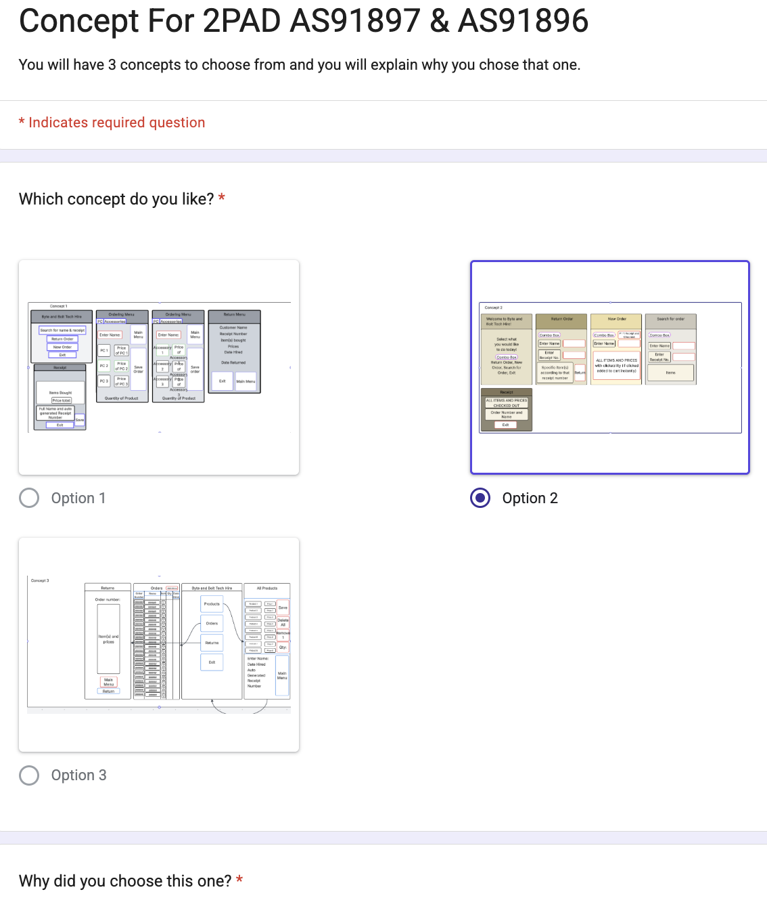
A screenshot of the google form in its entirety.

(Which collaboration tool have you chosen? How are you going to keep logs? How will you share your feedback in this project?)
I have chosen Clickup as my collaboration tool, so that I have direct access to other collaborators on documents such as planning with my Trello board, my Gantt chart, as well as helping act as a central point to look throughout my project. I will eventually link all of my version controls (through GitHub of course) to the Clickup page, but as of now I have no plans to do so, as I have yet to code.
Version Control:

- Saving backup copies with a logical file naming system

(Add a snip from your file explorer/or other version control software of the versions you have created)

- using simple version control software applications (this can be GitHub, File Explorer or other)

Justify your Version Control Tools chosen:

Component 1: (STATE WHAT IS YOUR CHOSEN COMPONENT HERE)
Trialling : | (Snip 3 to 4 different component concepts of your GUI’s component you are trialling here. e.g. If you are trialling functional component such as list vs radio buttons etc)
Evaluation of Response: | (Add snip of results/feedback or recordings here, this could be a pie graph of results or logs of responses, the more feedback the better)  (Add your evaluation of the responses here)
Which did I choose and why?

Component 2: (STATE WHAT IS YOUR CHOSEN COMPONENT HERE)
Trialling: | (Snip 3 to 4 different component concepts of your GUI’s component you are trialling here. e.g. Different Layouts using Geometry and/or Canvas)
Evaluation of Response: | (Add snip of results/feedback or recordings here, this could be a pie graph of results or logs of responses, the more feedback the better)  (Add evaluation of your responses here)
Which did I choose and why?

Component 3: (STATE WHAT IS YOUR CHOSEN COMPONENT HERE)
Trialling Iteration: | (Snip 3 to 4 different component concepts of your GUI’s component you are trialling here. e.g.)
Evaluation of Response: | (Add snip of results/feedback or recordings here, this could be a pie graph of results or logs of responses, the more feedback the better)  (Add evaluation of your responses here)
Which did I choose and why?

Final:

(Add snips below of your Final GUI interface after the trialling process)

Evaluation:

In the space below add critical reflection/evaluation of project management tools:

(Add answer here)

Reflect on the evaluation of trialling, testing and feedback e.g. Did the Technological Process (Iterative design process) help you with your project? If so, how?

(Add answer here)

Explain how addressing the Relevant Implications of your project helped in developing your outcome.

(Add answer here)

GRADE: N / A / M / E Students Name:____________________
Assessment schedule/Mahere Aromatawai: Digital Technologies & Hangarau Matihiko 91897 Use advanced processes to develop a digital technologies outcome
Evidence/Judgements for Achievement/Paetae | Evidence/Judgements for Achievement with Merit/Kaiaka | Evidence/Judgements for Achievement with Excellence/Kairangi
Use advanced processes to develop a digital technologies outcome. | Use advanced processes to develop an informed digital technologies outcome. | Use advanced processes to develop a refined digital technologies outcome.
The student has:  ◻ Concept designs  ◻ A Flow Chart  ◻ Used 2 recognised and appropriate project management tools and techniques to plan and manage the development of a digital technologies’ outcome.  ◻ Trello Board  ◻ Gantt Chart  ◻ Other………………….  ◻ Decomposed the digital technologies outcome into smaller components used 1 Decomposition Tools:  ◻ To Do Lists  ◻ Decomposition Table  ◻ Mind Map  Project Management Technique used:  ◻ Waterfall  ◻ Agile  Collaboration Tool used:  ◻ Google Docs/Forms  ◻ Interviews (with interview logs)  ◻ Emails  ◻ Survey Monkey  Version Control:  ☐ Clear folder and file names with version numbers  Trialling:  ☐ Broken their outcome down into a series of components. For each component they have created a piece of code and trialled it with feedback.  Evaluation Tool:  ☐ Provided a snip of their final GUI.  ☐ Provided a brief reflective summary of the development process  ☐ Explained at least three Relevant Implications (paragraph for each required) | The student has:  Project Management Tools:  ☐ Selected the most viable PM tools to use  ☐ Selected and justified the most viable Methodology to use  ☐ Provided evidence of using project management tools and techniques to effectively manage the development of a digital technologies outcome  Version Control:  ☐ Used version control tools to effectively manage the development of a digital technologies’ outcome  ☐ Each file is named appropriately with a version number and date.  ☐ They have created a GitHub and/or file explorer document with snips demonstrating version control  Collaboration/Trialling:  ☐ Trialled alternate ways of getting user input  ☐ Evaluated evidence from their trialling, testing and feedback to inform their decisions to update their project plan  ☐ Provided a critical evaluation of why they agreed/disagreed with their respondents on GUI design choices.  Evaluation of Trialling/Testing and Feedback Implications:  ☐ Provided a critical evaluation of PM tools  ☐ Evaluated the testing and trialling process appropriately, may have linked this process to improve the functionality of the digital technology’s outcome  ☐ Addressed relevant implications throughout the project | Reflection and Justification  ☐ Discussed how the PM tools guided or hindered the development process.  ☐ The student presents a reflective summary of how the information from planning, testing, and trialling of the components of their hire program assisted them to develop a high-quality outcome.  ☐ Provided annotated screen shots or detailed description of the changes they have made throughout the process and how feedback from the users and the testing process helped them to refine their program.  ☐ In-depth analysis of relevant implications throughout the project and evaluation
 | Grade | N | A | M | E
Comments:
Final grades will be decided using professional judgment based on a holistic examination of the evidence provided against the criteria in the Achievement Standard

